Bahria University,

Karachi Campus



LAB EXPERIMENT NO.

5

LIST OF TASKS

|  |  |
| --- | --- |
| TASK NO | OBJECTIV  E |
| 1 | While utilizing the Linux commands studied so far, provide an example (other than the one shown in this Lab) of a combination of several Linux commands in which pipes are used more than once. Also provide a snapshot of the generated output. |
| 2 | Write C program to print all alphabets from a to z using while loop |
| 3 | Write a shell script that records the full path of all the files present within a directory into a record.txt file. Along with full path name, the script should also record the number of words, characters and lines within each file |
| 4 | Write a C program that takes values of two matrices of size (𝑚×1) and (1×𝑛) as input from the user. Multiply the above two matrixes and store the resulting (𝑚×𝑛) matrix in a 2D array. Display the contents of the first and second matrices and also the resulting matrix.  Achieve alignment in the displayed content as much possible. |

Submitted On:

17/4/2022

( Date: DD/MM/YY )

Task# 01:- While utilizing the Linux commands studied so far, provide an example (other than the one shown in this Lab) of a combination of several Linux commands in which pipes are used more than once. Also provide a snapshot of the generated output.

Solution:-

cat file2.txt | sort | uniq

Output:-

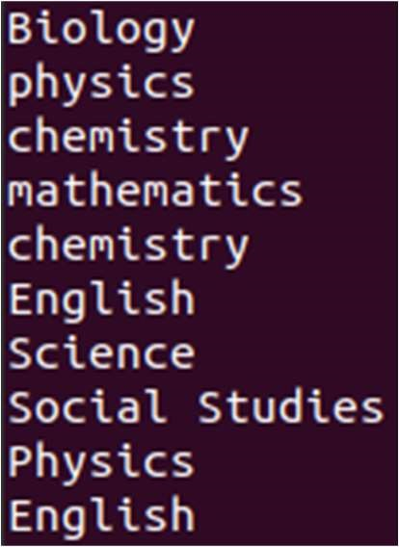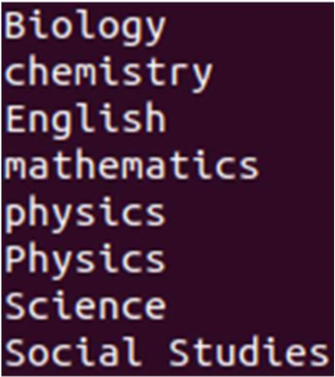

Task # 02: Write C program to print all alphabets from a to z using while loop

Solution:- int main()

{

int ch = 97;

printf("Alphabets from a - z are: \n");

while(ch<=122)

{ printf("%c\t", ch); ch++;

} printf("\n"); return 0;

}

Output:-

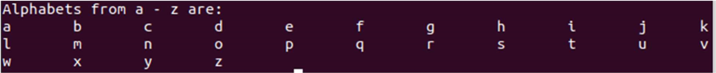

Task#03:- Write a shell script that records the full path of all the files present within a directory into a record.txt file. Along with full path name, the script should also record the number of words, characters and lines within each file

Solution:-

ls -d "$PWD"/* > listOfFiles.list

Output:-

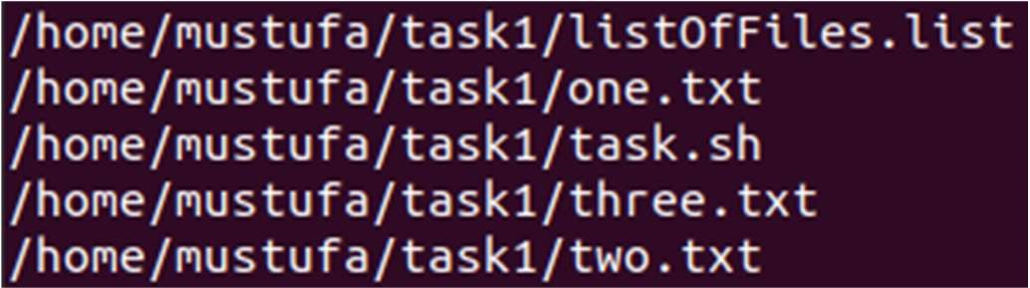

Task# 04:- Write a C program that asks the user to provide an integer input in the main() function. The program would call a function even_odd() from the main() function, where the function even_odd() accepts an integer as an argument, determine and display if the passed integer is either even or odd.

Solution:- void even_odd(int a) { if ( a % 2 == 0 ) { printf("it is even number\n");

} else {

printf("it is odd number\n");

}

}

int main() { int num;

printf("Enter a number\n"); scanf("%d",&num);

even_odd(num);

}

Output:-

